Software Requirements Specification
for

Travel agency Management System
Version 1.0 approved
Prepared by Team 3
Travelers™
30/10/2020
Table of Contents
1. Introduction 1
1.1 Purpose 1
1.2 Document Conventions 1
1.3 Intended Audience and Reading Suggestions 1
1.4 Product Scope 1
1.5 References 1
2. Overall Description 2
2.1 Product Perspective 2
2.2 Product Functions 2
2.2.1 Sign-in: 2
2.2.2 Sign-up: 2
2.2.3 Admin menu: 3
2.2.4 Agent confirmation: 3
2.2.5 Agent menu: 3
2.2.6 Add/remove packages: 3
2.2.7 Confirm orders: 3
2.2.8 Contacts: 3
2.2.9 Lead list: 4
2.2.10 Customer menu: 4
2.2.11 Search Engine: 4
2.2.12 Order package and payment: 4
2.2.13 Watch ordered packages: 4
2.2.14 Cancel orders: 4
2.2.15 Friends list: 4
2.3 User Classes and Characteristics 5
2.4 Operating Environment 5
2.5 Design and Implementation Constraints 5
2.6 User Documentation 5
2.7 Assumptions and Dependencies 6
3. External Interface Requirements 6
3.1 User Interfaces 6
3.2 Hardware Interfaces 6
3.3 Software Interfaces 7
3.4 Communications Interfaces 7
4. System Features 7
4.1 Search Features: 7
4.1.1 Customer Support Reply: 7
4.1.2 Stimulus/Response Sequences: 7
4.1.3 Functional Requirements: 7
4.2 Contact Features: 7
4.2.1 Customer Support Reply: 7
4.2.2 Stimulus/Response Sequences: 8
4.2.3 Functional Requirements: 8
4.3 Package Database editing 8
4.3.1 Opportunity quality evaluation 8
4.3.2 Stimulus/Response Sequences 8
4.3.3 Functional Requirements 8
4.4 Find Traveling Companions: 8
4.4.1 Opportunity quality evaluation: 8
4.4.2 Stimulus/Response Sequences: 9
4.4.3 Functional Requirements: 9
4.5 Lead list: 9
4.5.1 Opportunity quality evaluation: 9
4.5.2 Stimulus/Response Sequences: 9
4.5.3 Functional Requirements: 9
5. Other Nonfunctional Requirements 10
5.1 Performance Requirements 10
5.2 Safety Requirements 10
5.3 Security Requirements 10
5.4 Software Quality Attributes 10
5.5 Business Rules 10
6. Other Requirements 11
Appendix A: Glossary 11
Appendix B: Analysis Models 11
Appendix C: To Be Determined List 11

Revision History
Name | Date | Reason for Changes | Version
Team 3 | 30/10/20 |  | 0.1
Team 3 | 7-9/12/20 | Updates following DFD, UseCase and code | 0.2

Introduction

Purpose
The purpose of this SRS file is to describe all of the requirement and the development attributes in detail, so the developers the customers and the investors will be able to know what to expect from the product.

Document Conventions
The programmer will be built in C++ the requirement order is from high priority to low priority.

Intended Audience and Reading Suggestions
This SRS document is intended to be read by developers, project managers, marketing staff, users, testers, and documentation writers.

Product Scope
The purpose of the software is to enable customers to buy easily travel packages and for the travel agency to be able to monitor and control the Database of the reservations its benefits are that the travel agent will save a lot of time and man power by using the software, because the customer can do most of the work themselves by filling the forms and "order requirements".

References
SRS template
Stack Overflow web
Geeks for Geeks

Overall Description

Product Perspective
This system is for people that want to buy a packages flights in easy way.
The customer can search flights and hotels for him vacation. He can also find friends in his flights and contact with them.
If the customer has a problem, he can send a message to travel agency.
The advantages of the system are that it is easy to use, it has many options for the user.
This system is a new system that will be using existing services including PayPal, airlines agencies, wire transfer systems via banks, hotels management services and more.

Searching for a deal

Waiting for travel agent approval

Airlines

Completing order
Banks
Hotels

Insurance

Product Functions

Sign-in:
There are 3 types of users:

Admin:
the system recognizes the details and sign in the user as admin.
Agent:
the system recognizes the details and if the admin confirmed the agent he signs in as an agent and if not, he sign in as a customer.
Customer:
The system recognizes the details and sign in the user as customer.

Sign-up:

when the user signs up he asked for a strong password:
minimum one upper letter, minimum one lower letter and minimum one number.
The length of the password will not be less than 8 chars.

There are 3 types of users:
Admin:
Already exists in the system and can’t sign up.

Agent:
Put his details and sign up as a customer until the admin change him to agent.

Customer:
Put his details and sign up as a customer.

Admin menu:
The admin can change the agent’s users from customer to agent, in addition he can go to agent menu and use all the options there.

Agent confirmation:
Only admin has access to this function.
All the users DB show and the admin can change customer users to agent users.

Agent menu:
The agent/admin can add and delete packages from the DB, he can confirm customer orders or cancel the orders. He also can watch lead list and answer to customer messages.

Add/remove packages:
The agent/admin will be able to add/delete a package from the DB

Confirm orders:
The agent/admin be able to monitor the orders and change their status- confirm or cancel.
If the agent/admin confirm the order the order DB and the packages DB updates.

Contacts:
The customer can leave a message to the travel agency. The messages are adding to messages DB.
The agent/admin can see the messages and return the customer by the details that the customer put- email / phone number.
When the agent/admin take care a messages it deletes from the messages DB.

Lead list:
The agent/admin can watch lead list.
customer who made order in this system add to the order DB. The lead list is a customer list from this DB.
The agent/ admin can sell this lead list.

Customer menu:
The customer will be able to search for a package, to send a message to the agent/admin, he will be able to see the existing orders status and cancel an order if he wants. In addition, he can watch friend list If he chooses this option.

Search Engine:
The customer can search packages by some necessary categories like: date of departure and return date, destination- to and from and number of passengers. He can also fill what is the max price or the min price that he wants to pay.

Order package and payment:
The customer can choose a package from the list that was suggested to him by search engine.
He needs to fill in detail and methods of payment, the system will have secure billing system, the user is required to enter his card CVV to complete the order.
In the order the customer can mark if he wants to be in friends list.
After the customer order a package this order add to order DB.

Watch ordered packages:
The customer can see his ordered packages. He can see their status and can cancel them.
In addition, he can choose to watch friends list if he marked it when he made the order.

Cancel orders:
If the customer wants to cancel his order. he will be asked again if he sure that he want to cancel.
If he chooses yes, the order will be delete from order DB, add to packages DB.
In addition, the external companies will be updates

Friends list:
If the customer chooses while he order package that he want to be show in friends list he can see the list of the customer that also choose this option.
He can filter the list by gender and age group.
In the list will be shown the details of the friends like email and phone number and they can contact each other.

User Classes and Characteristics
Travel agent- can control the database change order statues (to approve or cancel the reservation), add new traveling packages, see and answer messages left by customers.
The agent can also watch in lead list- a list of customers who did reservation.

Admin- have the same permissions as an agent, additionally he can change customer users to agent users in users DB.

Customer- can find traveling packages and send reservation request, can also leave a message for a travel agent and can view information on the packages including hotel flight and more specifications and can also cancel his order if he want to.
The customer can find new friends to travel with them, he needs to mark this option when he makes the order. after that he can see the list of the people that with him in vacation that choose the same option of friends list.

Operating Environment
As for now the program for the travel agents is intended to run on windows OS, the customer will be able to interact with the system through web browser and an app for android OS an iOS

Design and Implementation Constraints
The software depends on high internal memory of the computer, be it RAM or HDD and its permutations.
The developer must have access to the employee database.
There must be an established internet connection to secure payment transaction.
This software depends on external payment processing application services and relays to external database which is not maintained by the software.
This software depends on external hotel and flight reservation systems.
There is a limitation to the usage of its features by different users based on roles (manager/employee).
Software’s security must be assigned by the customer and customers own programming team as required by its own security protocols.
The customers organization will be responsible for Integrating/maintaining the delivered software.

User Documentation
The travel agents/admin will be trained on how to operate the system and the database and there will be a manual specifying how to do every operation.

Assumptions and Dependencies
- Our assumption that we have a server which will store the account and order database
- The database includes details of access for each user such as Travel Agent & Customer & admin stated by Role.
- The system depends on outsourcing payment transactions to specified systems such as PayPal etc.
- The System will know how to communicate and order hotel and flight reservations.

External Interface Requirements

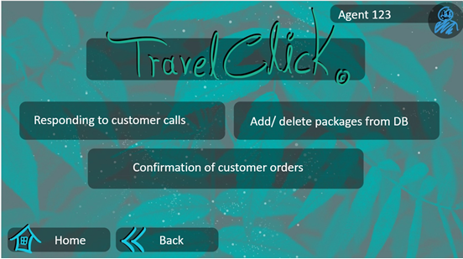
User Interfaces

The software will have user log in UI and for the customer search engine
And for the travel agent menu for controlling the database.
See the prototype presentation (style may differ from the final product).

Hardware Interfaces
The application requires a monitor and working computer with Windows OS installed with mouse and keyboard and for the mobile app an updated version of android or IOS
and local internet access.

Software Interfaces
- The system will be linked with a payment system, such as 'PayPal'.
- The application will have access to data base that was written by a third-party software program (in a .txt format).
- The system can also be shown on the internet browser.

Communications Interfaces
- The system requires local internet connection to access the services all the messages left by the customer will be delivered via email to the traveling agent/admin.
- Communication with human resources databases to transfer data into the software.
- The system will be able to communicate with banking, hotel and flight management systems.

System Features

4.1 Search Features:

4.1.1 Customer Support Reply:
The search engine will provide us the deals we search for in the database according to the categories that will be selected by lists of options and will be ordered by the lowest price.

4.1.2 Stimulus/Response Sequences:

The user will have to log in into the system order to access the database,

From the search menu we user will have the option to order packages after filling

His categories and then the search engine will display the deals by the lowest price

To most expensive that found from database.

4.1.3 Functional Requirements:
The error messages will appear as result of incorrect input in each field and briefly explain the error and then the system will ask the user for a valid input.

4.2 Contact Features:

4.2.1 Customer Support Reply:
If the customer filled a contact request the request will be sent to a general email
which all the travel agents will have access to be able make a faster reply to the customer.

4.2.2 Stimulus/Response Sequences:
In the customer menu will be contact option in case the customer will want to
Make a request about contacting him

4.2.3 Functional Requirements:
The user must log in and fill valid email/phone number order to complete the task.

Package Database editing

4.3.1 Opportunity quality evaluation
This feature enables the travel agent/admin to get into the packages database find specific orders and watch the details of this order. they can also and add packages or delete packages from the DB.

Stimulus/Response Sequences
The travel agent/admin will have to log in to his account. After the log in he can see this option on his menu.
He will be able to edit packages DB. He can find specific package by searching by package number and after it he can delete this.
He can also add a new package.

Functional Requirements
Only travel agent/admin can access the mentioned feature
The admin/travel agent’s workflow will closely follow the sequence of actions shown in the Flow Chart (see Appendix B).
The travel agent/admin must enter valid information and can't change sensitive information like billing information without the bank confirmation.

Find Traveling Companions:

4.4.1 Opportunity quality evaluation:
This feature enables the customers to be able to communicate and find other customers who go to the same destination and help them have "soft landing" in the country they are flying to.
When a customer orders a package, he needs to fill a checkbox if he wants to be able to be seen by other customers, the list of the potential companions will be shown in the package details page.

Stimulus/Response Sequences:
The customer will have to log in to his account on the main screen and get in the package details screen.
He will see a list of "potential companions" with contact information.
In order to be shown there he the customer will have to check a checkbox that says, " allow to share contact information with potential companions." on the payment page.

Functional Requirements:
Only customer can access the mentioned feature
The customer's workflow will closely follow the sequence of actions shown in the Flow Chart (see Appendix B).
The customer will be able to see others details only if he shares his own contact information.

Lead list:

4.5.1 Opportunity quality evaluation:
This feature enables the agent/ admin to watch and sell lead list.
When the customer made a reservation, his details saves in ordered DB. From this DB the agent/admin can watch this customer and filter this list by their required. they can do a Collaborate with other companies- like sell a list of the people that go to ski vacation to stores of ski supplies.

4.5.2 Stimulus/Response Sequences:
The agent/admin will have to log in to their account. They can see this feature on the main screen.
After they choose this feature all the list of the customer who did a reservation in the past appear.

Functional Requirements:
Only agent/admin can use this feature.
There needs to be a division in order DB so they can sell the leads to suitable companies.
The customer gets a message when he ordered package that the company will send him Affordable offers.

Other Nonfunctional Requirements

Performance Requirements
All the screens will load in 3 seconds.
After the package is ordered it will be added in real time to ordered DB and deleted from packages DB. And if the order is cancelled the quantity in packages DB update and this package will be deleted in real time from ordered DB.
All the sync with the external companies happens in real time

Safety Requirements

There is a possible of loss of data that could result from communication gaps with hotels and flights agency. The significant damage is leakage of personal bank details, which is under responsibility of PayPal and other 3rd party secure Money Transfer App, the database will be backed up in several cloud servers every day at 9 PM.

Security Requirements

The product will contain a file of a large database containing personal details of potential customers. The users of the system will be having to use hard to crack code, they will have to include uppercase letters and numeric characters. The internal database will be encrypted to prevent leakage of those personal details such id, sensitive data, passport etc.

Software Quality Attributes
- The product is easy to use.
- The product provides reliable information about every offer.
- Up to date technology.
- The product will be available to every member of the sales department and to every client.
- Flexible and modular system for changes according to future requirements

Business Rules
- Only a travel agent can update the packages and accesses all the available reports in the system.
- Only a travel agent can approve order and have access to Data base of the clients.
- Only the travel agent/admin can view the lead list order to offer the customer to be contacted by traveling stores for discounts /sales

Other Requirements
All requirements were mentioned above.

Appendix A: Glossary
DB- data base
OS- operation system
IOS- iPhone operation system
RAM- random access memory
HDD- hard disk drive
UI- user interface
ID- Identity number

Appendix B: Analysis Models

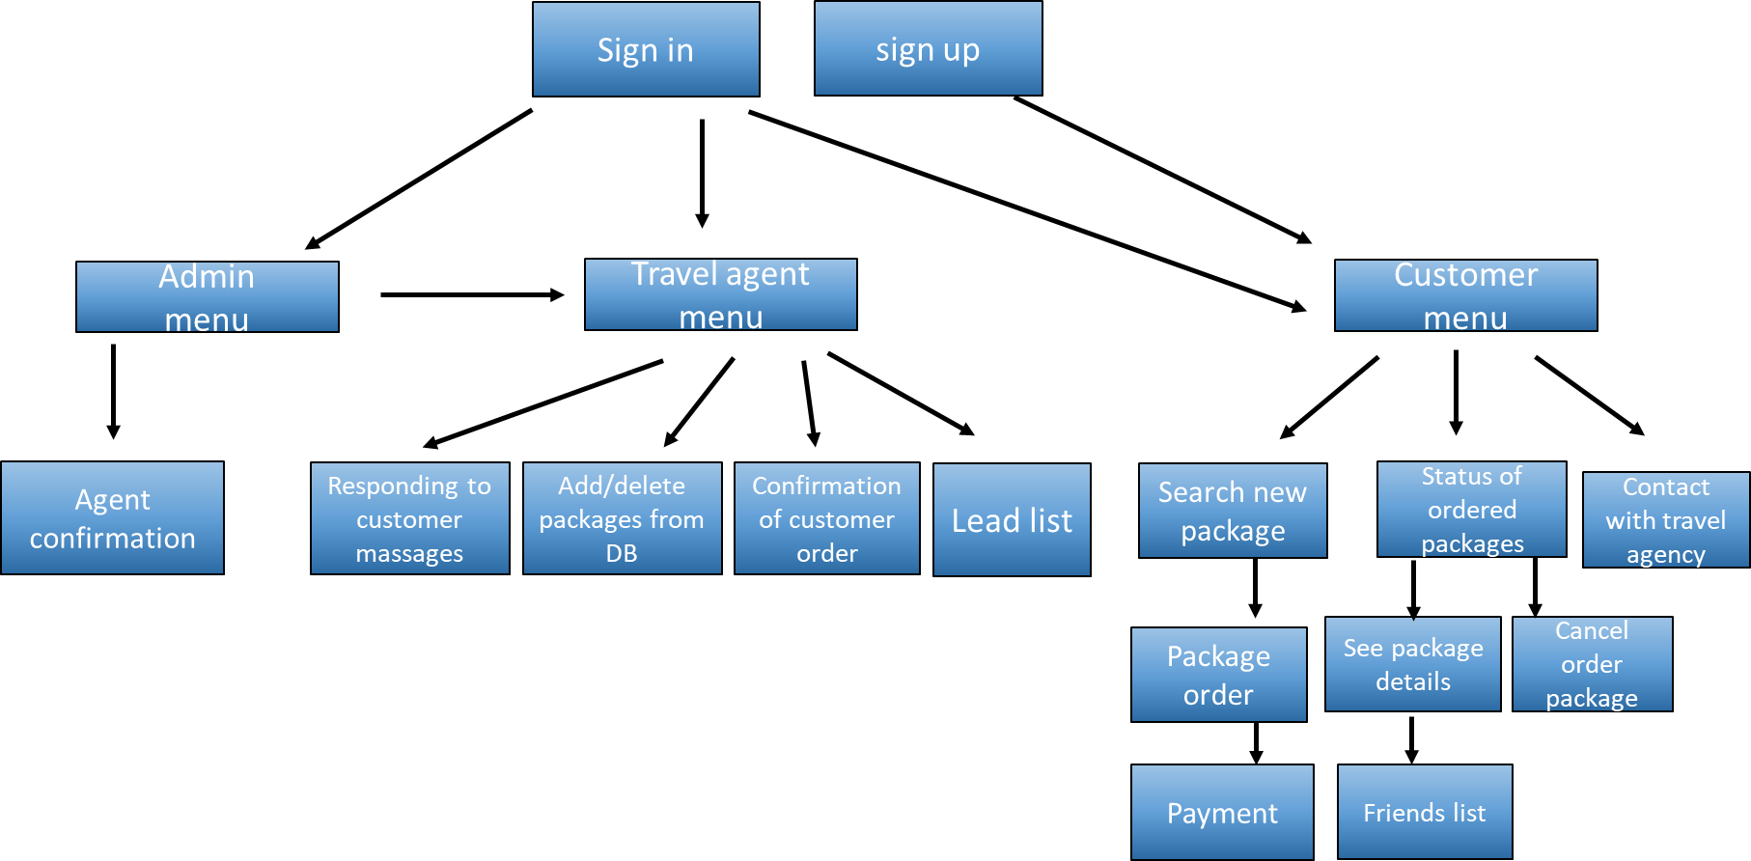

Appendix C: To Be Determined List
- Interface design
- Software menu
- Data encryption algorithm
- Secure payment
- Search Engine
- Database requests of one sub-procedure

